**"WISE Girls"**

Women Inspiring Success and Empowerment

1. **Define the goals and objectives of the platform**

* Create a helping platform that offers mentoring to encourage and inspire young girls to pursue jobs in various fields.

1. **Identifying target audience**

**3. Technology**

* End product: Website

3.1 Creating logo



or



3.2 Home page

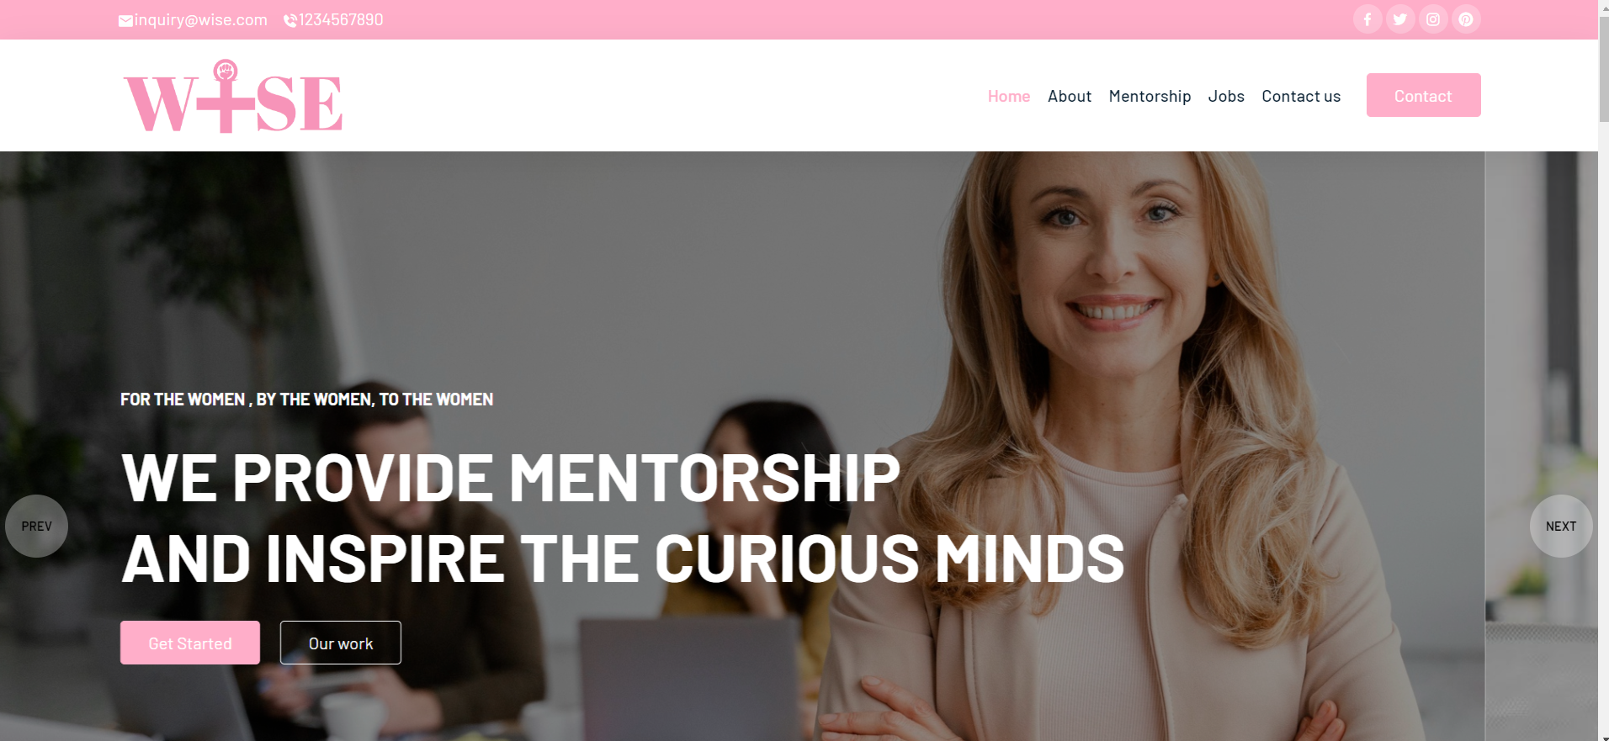

**4. Launch the platform (Mostly in github.io)**

Launch the platform and start promoting it through various channels to reach your target audience.

**5. Continuously improve:** Continuously gather feedback and improve the platform to meet the needs of the young girls and mentors.

**Future Work:**

1. Offer interactive features such as chatbots, discussion forums, and webinars to help young girls connect with mentors and peers.
2. Women in Research
3. Direct applying to jobs features
4. Introducing Paid module:
5. From mentors (commission)
6. From mentees
7. Jobs publish
8. Applicants